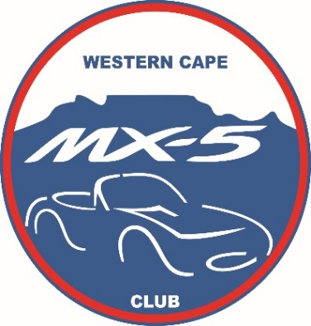
WESTERN CAPE
MAZDA MX-5 CLUB
Chairman: Bernie Koch | chair@mx5wc.co.za | 083 454 3776 | Secretary: Joanita Koch | secy@mx5wc.co.za |
084 553 3760 | Treasurer: Gerald Poswell | treas@mx5wc.co.za | 083 659 2544 | Events: Brian Roy | events@mx5wc.co.za | 083 763 1291 | Webmaster: Jonathan Dekel | webmaster@mx5wc.co.za | 074 819 6119 | Facebook: Rod Manson | fbook@mx5wx.co.za | 073 661 8613
Please visit us at: www.mx5wc.co.za & on Facebook

CHAIRMAN’S REPORT: CAFÉ ROUX 2016-09-25.

With Treasurer Gereld Poswell in charge of things, one thing will always be certain: we will be guaranteed a good scenic drive!

And this day was no exception: we rendezvoused at Mc Donald’s at Plattekloof as well as the Alphen Clinic in Constantia Main road. From there we left and travelled across Chapman’s Peak where we stopped at a lookout point for some bubbly and a short presentation by Hans Matter of the forthcoming Killarney Motor show. (This is to be held on Sunday 6 November 2016 – please remember to diarize.) Toll fees for Chapman’s Peak were paid for by the club. From there we left for Café Roux at Noordhoek Village for lunch.

The Club was joined on this outing by Owen Willoughby, the artistic director for Top Gear Magazine. Owen currently has a MK4 for a long term test and joined us on the outing in order to meet the Club and it’s members. I found Owen a very interesting young man and judging by what I saw today, I will not be surprised if one day we see him in his own Mazda MX-5 and as a member of this Club!

Our October meet is again scheduled for not-the-last-Sunday of the month: remember to diarise the 23rd! George Slade will be in charge of things and that always promises something good!

Regards to all

